Step by step: A tool for harm reduction service providers

Policy document template

1. Introduction

1.1. Scope of policy

This policy document details [organisation]       approach to dealing with children and young people under 18 who inject drugs. This policy outlines both the services we provide onsite and services we provide via referral. This policy documents the responsibility we have to the children and young people we encounter, and our approach to addressing the wider protection needs of children. It addresses potential challenges staff may encounter when working with children and young people including consent, confidentiality and evolving capacities.

This policy document is the result of a comprehensive and participatory process undertaken by staff at this organisation to ensure that [organisation]       is prepared and well equipped to support children and young people who inject drugs.

1.2 Background to [organisation]       and harm reduction

[Insert background information on your organisation and its values and approaches to harm reduction. For example, when was your organisation founded? How many staff do you employ? What areas do you serve? What services do you provide? What are the values, mottos and mission of the organisation?]

1.3 Children and injecting drug use

[Organisation]       recognises that children and young people who inject drugs need our help now. We recognise that children and young people who inject drugs are increasingly vulnerable to HIV and other harms compared to older people who inject, and therefore require specific attention.

[Organisation]       recognises that harm reduction services play a crucial and necessary first step in protecting the child from unnecessary harms in order to ensure their survival and well-being, so that their wider psychosocial needs can also be addressed.

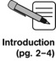

List some of the main points and arguments that demonstrate the need to work with children and young people and support your decision.

Add any data you have gathered on the situation of children and young people who inject drugs in your country. Be sure to add references and sources used.

2. Guiding principles

2.1 Organisational values

[Organisation]       recognises that children and young people under 18 who inject drugs are highly vulnerable and may have different needs compared to older people who inject. As an organisation, we hold the following values towards children and young people:

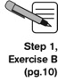Record your shared values here.

2.2 Competency and consent

[Organisation]       recognises the challenges with providing services to children and young people under 18. We recognise that children may or may not possess the capacity to make decisions on their own behalf. We understand that children and young people differ in terms of maturity and understanding, which affects their ability to make informed decisions.

Summarise and insert the principles related to the CRC and the ‘best interests of the child’ and other legislation and principles that support your work.

Note the approach your organisation will take in determining the evolving capacities of children and young people.

2.3 Confidentiality

[Organisation]       recognises the importance of ensuring confidentiality of all clients that utilise our services. We understand the increased sensitivity of working with children and young people, and recognise that some circumstances may require confidentiality to be breeched when acting in the best interest of the child.

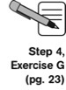Document the steps your organisation will take to ensure confidentiality, including under what conditions the breach of confidentiality may be warranted. Describe how this information will be shared with staff members and clients.

3. Legal and policy context

3.1 Legal and policy environment

[Organisation]       recognises the existence of laws and policies that influence and shape the way in which we work with children and young people who inject drugs.For example: In the UK, all reported cases of abuse must be reported to managers (Children Act 1993); No legal age restriction is placed on the provision of sterile injecting equipment, but parental consent is a legal requirement (Child Protection Act 2001).

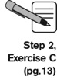List the main legal permissions, obligations and limitations that are relevant to work with children who inject in your country. Also include pertinent government policies around harm reduction, children and young people.

4. Operational processes

[Organisation]’s       approach to working with children and young people who inject drugs is a reflection of the following legislative and international normative frameworks around working with children.

Include the major international frameworks that apply to your work and can be used to support your policy.

[Organisation]       believes that in order to best serve children and young people who inject drugs we need to provide an opportunity for them to express their needs. [Organisation] supports the participation of children and young people in making decisions that will affect them. Through consultation with children and young people who access our services, we understand that children have the following service needs.

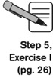List the main needs for services expressed by children and young people during the focus group discussions.

4.1 Services provided directly to children who inject drugs

[Organisation]       recognises the legal context in which we work as well as our obligation and duty of care to promote the health and well-being of children and young people who access our services. [Organisation]       offers the following services to all clients, and will extend these services to children under 18.

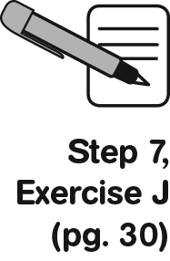List the services your organisation will provide directly to children and young people of the main points that support your decision to work with children who inject drugs.

4.2 Referral process

In addition to the services listed above, [Organisation]       will provide the following services to children through referral with local providers:

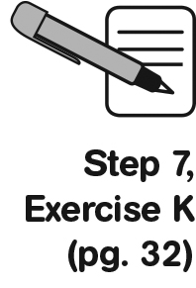List the services your organisaton will provide to children and young people via referrals. This will reflect the services that Exercise J determined to be a priority for children and young people, but will be provided via referral due to low capacity, high risk or both.

[Organisation]       has developed the following procedures to provide referrals and monitor and track to ensure quality and accountability.

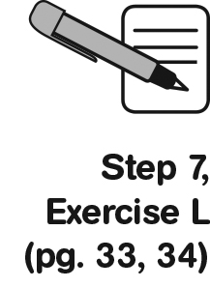Include ideas from discussions on monitoring and tracking referrals and keeping a referral register.

4.3 Participation of young people

[Organisation]       recognises that children and young people themselves are best placed to comment on their needs and challenges. We are committed to providing the space and opportunity for children and young people to participate in the decision making process as it relates to them.

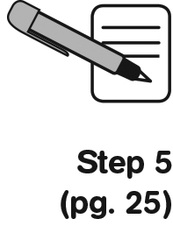Revisit Step 5 and discuss how your organisation will ensure that the opinions of children are solicited and considered/how you will ensure the meaningful engagement and participation of children and young people.

[Organisation]       takes the following steps to ensuring the voices of children and young people are considered: The feedback of children and young people will also help [Organisation]       to ensure the ongoing quality of our services.

Document how you plan to collect feedback from the children and young people who use your services.

4.4 Well-being of staff members

[Organisation]       recognises the potential for emotional distress when providing services to children and young people who inject drugs. [Organisation]       is committed to ensuring the well-being of our staff to ensure that they feel supported and encouraged and are able to work effectively to meet the needs of the children and young people we serve.

Outline the steps you will take to mitigate any negative emotional effects on staff. What support is available?

5. Ensuring child protection

[Organisation]       is committed to ensuring the protection and safeguarding of children and young people we encounter from harm as a paramount component of our work. [Organisation]       is committed to providing a safe and positive environment for children and upholding our duty of care towards the children and young people who attend our service.

Our child protection policy will ensure that all staff members understand their responsibility and duty of care towards children and young people who inject drugs that are encountered by our organisation. It also ensures that staff are aware of the steps they should take if concerned about the safety and wellbeing of a child.

Outline your child protection policy and the steps an employee should take if they are concerned about the well-being of a child or young person. Refer to or include the code of conduct.