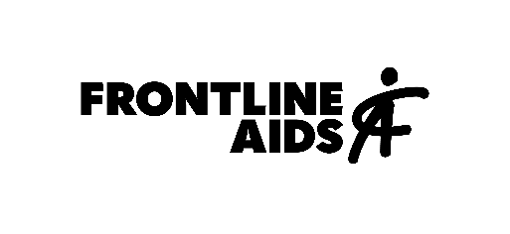

APPLICATION FORM
HIV Prevention Advocacy Grants

1. Organisation information

Name
Address
Focal person | Name:  Role:  E-mail address:
Organisation’s scope of work
(150-word max)
Populations you intend to work with | People who use drugs Men who have sex with men  Sex workers Adolescent girls and young women  Transgender people
Does your organisation require to get government / regulatory approval before receiving funds from an international NGO?

Are you already receiving other funding to implement HIV advocacy work? if yes, can you please list the sources of funding, and the rationale for needing more funding?

Are you in the process of requesting funding for HIV advocacy work to other donors/partners? if yes, when do you expect to know if your request will be approved?

2. Proposed area of work

Please, select from the list below your proposed area of work (you can select more than one where there are overlaps).

- Comprehensive Sexuality Education (CSE)
- New Prevention Technologies (NPT)
- Community-led prevention programming for key populations and for adolescent girls and young women
- Advocating against harmful / punitive laws and policies
- Harm Reduction
- Monitoring and accountability for existing prevention commitments
- Female Genital Schistosomiasis (FGS)
- Strengthening community systems (structures and processes) to support better health outcomes
- Diversifying financing options for communities and civil society

3. Proposal description

Title

Background
Identify the problem, providing data as necessary (400-word max.)

Goal and objectives
Please, describe the goal and list the proposed objectives (200-word max)

Methodology
Please, describe below: (700-word max)
- Proposed activities, outputs and outcomes.
- Proposed implementation timeline.
- Specific advocacy asks and targets.
- Stakeholders involved.

Foreseen risks
Please, describe potential risks you may face during implementation and how could you mitigate them (300-word max)
Sustainability
Please, explain whether the proposed work is part of a long-term process or a larger piece of work. Alternatively, explain how you intend to sustain the work beyond December 2021.
(300-word max.)

Resources
Please, explain whether the organisation has access to the appropriate resources and technical support to deliver the proposed activities or not. If the organisation does not have access, please list here and include in the budget.

4. Budget

- To complete this section, please use the excel template provided in the webpage.
- Complete the budget in your local currency / or USD if that is the currency you wish to operate with Frontline AIDS.
- Use Frontline AIDS currency exchange rates available in the budget template to work out the equivalent amount in your local currency.
- Include any costs for documentation or necessary technical support you may need throughout implementation.

5. Submission

Deadline: May 14th, 2021
Submission email: screspo@contractor.frontlineaids.org

Successful applicants will need to comply with Frontline AIDS due diligence processes; to develop a project M&E framework; as well as to complete project reports and share agreed monitoring data, i.e.: advocacy logs, stories of change, etc.

For additional information, please look at the FAQs section on the website, or reach out to: screspo@contractor.frontlineaids.org

